PromisePoint Mobile App
This qrg is a how to guide on using PromisePoint’s mobile app on an android device.

Download the app
- From your android device, select the Google Playstore:
- Search for “PromisePoint" and the icon should display as shown below.
- Tap on the PromisePoint app:
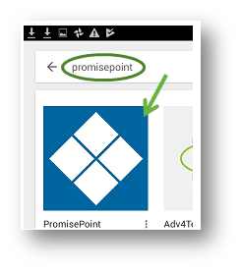

- Tap the INSTALL button, then ACCEPT to accept the installation:
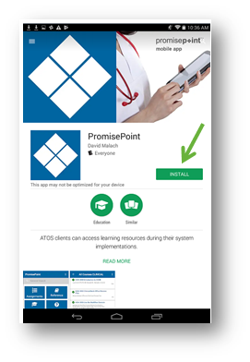
Start the app
- Tap OPEN from the app:
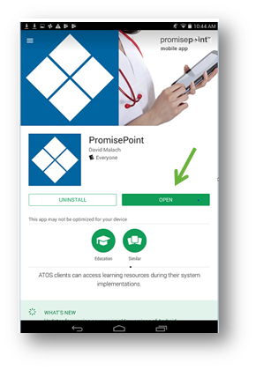
- Tap Continue when the Welcome screen displays.
- Enter your Client Code and tap Go.
Note: Typically this will be your organizations client ID code.
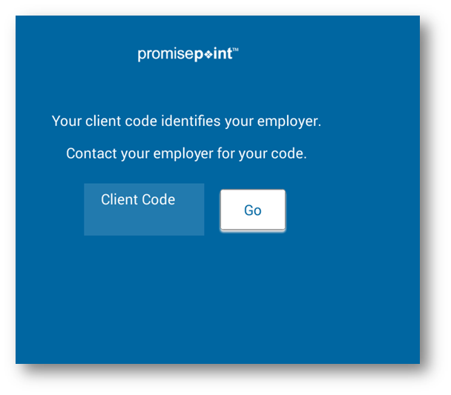
- Log in to PromisePoint using your username and password:
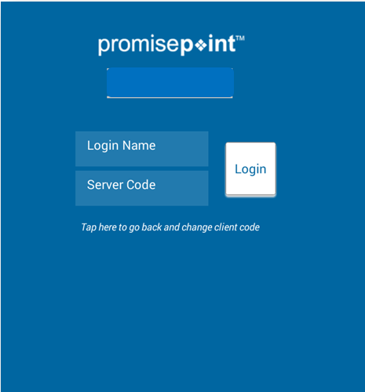

Using the options available
- Select Assignments, Resources, Transcripts or Help:
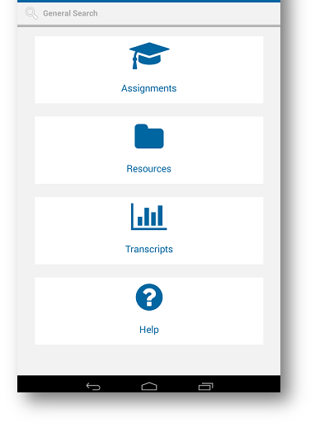
- Tap Assignments to access your learning.

- Curriculums assigned will display; tap the curriculum needed to access the courses:
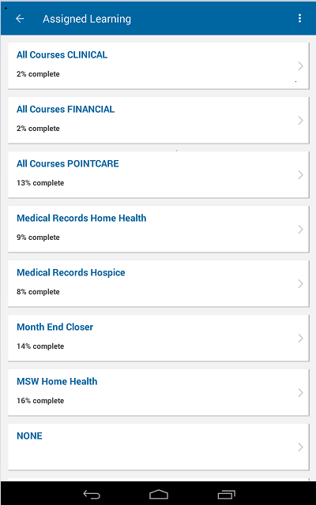
- Tap Resources to access documents.
Note: When accessing Resources be sure to have the application for the document installed on your device. For instance, the documents below are Microsoft Word. You will need Microsoft Word installed to view them.
- Select your categories until you have drilled down to the necessary document:
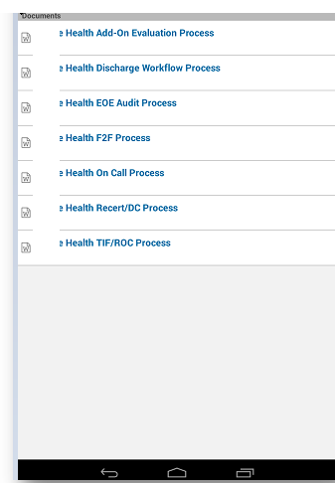
- Tap Transcripts to view your transcript report:

Note: The example below shows no learning activity yet.
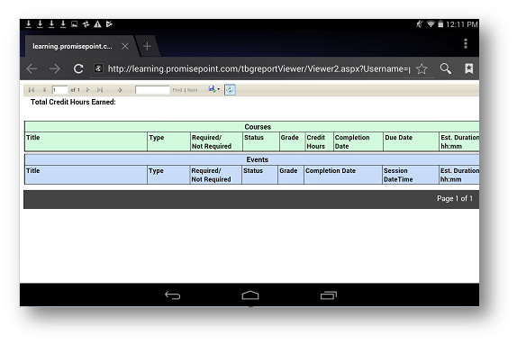
- Tap Help to bring up PromisePoint Helpdesk in an internet browser:
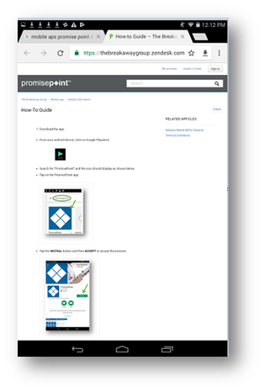
- Tap to key in a keyword to use the Search feature:
- Then, tap the magnifying glass:
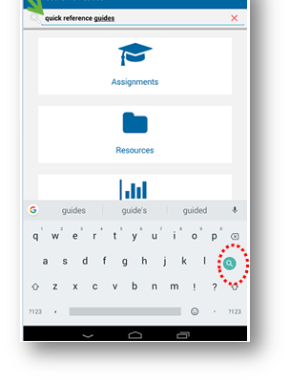
- Tap either category to view your results:
